INFRA AUDITS-ANALYSIS REPORT GENERATION

|  |  |
| --- | --- |
| **Name** | LOHITA V |
| **Roll no** | 7376221SE122 |
| **Seat no** | 192 |
| **Project ID** | 12 |
| **Problem Statement** | Infra Audits-Analysis Report Generation |

STACK

|  |  |
| --- | --- |
| FRONTEND | JAVASCRIPT |
| BACKEND | LAMP STACK |
| DATABASE | MYSQL |

# Introduction

**Purpose:**

The purpose of this document is to present a detailed description of the Infra Audits-Analysis Report Generation. It will explain the purpose and features of the system, the interfaces of the system, what the system will do, the constraints under which it must operate and how the system will react to external stimuli.

**Scope of Project:**

This website will work as a report generator and notification system. It generates reports based on weekly audits and send notifications to the designated employees responsible for addressing any negative remarks. Once an issue is resolved, the report will reflect the completion status and will be added in the report. If an issue requires additional time, the ongoing status will be indicated. The admin will have access to the weekly audits, ongoing works and the incomplete tasks.

# System Overview:

## Users:

**Auditor**:

They’ll have access to upload weekly audit plans, and remarks. They can also update their personal info stored in the system.

**Admins:**

Admins will have access to the

The auditable area

Ongoing task details

Auditor details

Weekly audit plans

Report generated based on the audit

Progress of the action taken by the work unit

**Work unit:**

These employees receive notifications regarding tasks assigned to them. They can access a login portal to:

View ongoing tasks

Update the progress of action taken

Upload photos of completed tasks (upon completion)

Mark tasks as completed (upon admin verification)

**Features:**

**Login page :** Provides access to user-specific portal

**Report Generation :** Generates report based on the weekly audits

**Dashboard** : To maintain the details of the auditors

**FLOW CHART**

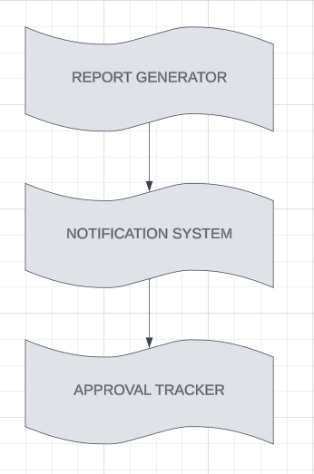

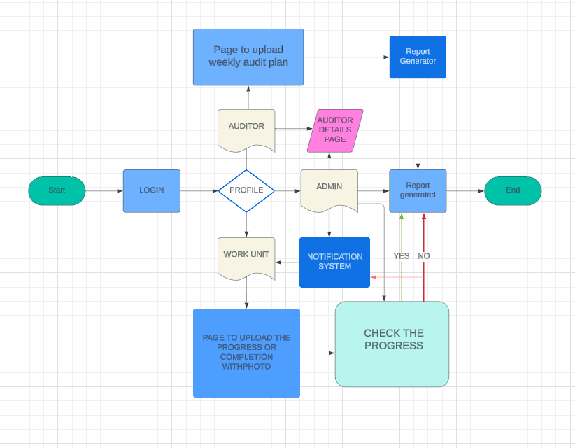

**REPORT GENERATOR:**

**Input Acquisition:** The generator obtains the physical file(s) containing the data to be included in the report. These files can be converted to excel spreadsheets.

**Data Parsing:** The generator parses the content of the physical file(s) to extract the relevant data. This involves understanding the structure of the file(s) and interpreting the data accordingly.

**Data Processing**: Once the data is extracted, the data will be segregated based on the need of the aid.

**Template Generation:** The generator uses the predefined template to organize the processed data into a readable report format.

**Report Generation:** Using the processed data and the template, the generator generates the PDF.

**Output:** The generated report is then presented to the admin